**JAVA SECTION 2 :**

**1.Simple ASCII art**

public class ProblemSet2_1 { public static void main(String[] args) {

// Use 8 print statements to print a smiley face.

// The art will rely on only a single character, besides space, such as X or #.

System.out.println(&quot; ##### &quot;);

System.out.println(&quot; # # &quot;);

System.out.println(&quot;# # # #&quot;);

System.out.println(&quot;# #&quot;);

System.out.println(&quot;# ### #&quot;);

System.out.println(&quot;# ### #&quot;);

System.out.println(&quot; # # &quot;);

System.out.println(&quot; ##### &quot;);

}

}

CORRECTED CODE:

public class ProblemSet2_1 { public static void main(String[] args) {

// Use 8 print statements to print a smiley face.

// The art will rely on only a single character, besides space, such as X or #.

System.out.println(" ##### ");

System.out.println(" # # ");

System.out.println("# # # #");

System.out.println("# #");

System.out.println("# ### #");

System.out.println("# ### #");

System.out.println(" # # ");

System.out.println(" ##### ");

}

}

OUTPUT:

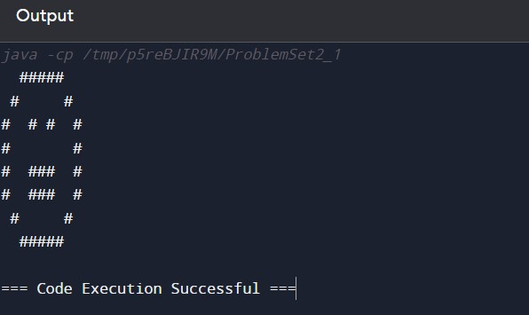

**2. Problem set2_2**

ASCII art is a graphic design technique that uses printable characters from the ASCII standard to

create images and designs. ASCII (American Standard Code for Information Interchange)

includes 128 characters, such as letters, numbers, punctuation marks, and control characters. By

carefully arranging these characters, artists can create detailed images, patterns, and representations of objects. public class ProblemSet2_2 { public static void main(String[] args) {

// This ASCII art depicts a simple house with a roof, a door, and windows.

System.out.println(&quot; /\\ &quot;);

System.out.println(&quot; / \\ &quot;);

System.out.println(&quot; /____\\ &quot;); System.out.println(&quot; | | &quot;);

System.out.println(&quot; | [] | &quot;);

System.out.println(&quot; |____| &quot;);

}

}

CORRECTED CODE:

public class ProblemSet2_2 { public static void main(String[] args) {

// This ASCII art depicts a simple house with a roof, a door, and windows.

System.out.println(" /\\ ");

System.out.println(" / \\ ");

System.out.println(" /____\\ ");

System.out.println(" | | ");

System.out.println(" | [] | ");

System.out.println(" |____| ");

}

}

OUTPUT:

